Ministry of Education and Science of the Russian Federation
State Educational Institution of Higher Professional Education

Lobachevsky State University of Nizhni Novgorod -
National Research University

Faculty for International Students

MANUAL of the course

INVESTMENTS
(Name of the subject (course)

Area of Studies
38.04.02. Management

Profile of training with instruction in English
Economics and Management of Financial Institutions

Qualification (degree) of graduates
Master

Form of training
full-time

Nizhni Novgorod
2014

CONTENT

LEARNING GOALS AND OBJECTIVES FOR THE COURSE 3
THE STRUCTURE AND CONTENT OF THE COURSE 4
WORKBOOK 5
1. Long term asset allocation: Overview 5
2. Fundamentals, valuations and analytical ratios (14 hours) 10
3. Managing portfolios for the long term 19
4. Venture investments and technological change (12 hours) 20
5. Global challenges and investment long-term risks 21
LITERATURE 22
Main literature: 22
Additional literature: 22
Internet resources 22

LEARNING GOALS AND OBJECTIVES FOR THE COURSE
This is an introductory course covering strategic investment for long-term asset managers. The course is designed to address the many challenges faced by asset managers investing strategically for the long term, focusing on discerning long term macro-economic trends. As a result students should be able to use both empirical and theoretically investment evaluation techniques. In addition the course will develop master’s skills in valuation and project presentation.
When have completed the course student will be able to:
- differentiate between strategic and portfolio investments;
- identify different types of long-term investment strategies based on the investment objectives, liquidity requirements, risk/reward characteristics;
- implement forecasting techniques and trend analysis for long-term investments;
- calculate the gain or loss from an investment deal (long-term investment project);
- outline expenses charged by different types of strategic investments;
- explain the accounting principles for investments deals;
- describe different financial strategies and policies that an investor must address;
- identify different types of mergers and acquisition deals;
- describe problems with performance evaluation of investment project;
- evaluate the risk profile of a long-term investment and describe the constraints faced by investors;
- choose a list of value-based drivers based on an investment plan;
- comment on when different types of financing are appropriate for a long-term investment;
- explain how the main principles of long-term investments have changed in a knowledge-based economy.
The main tasks of the discipline are the following:
- to explain the basic principles of long-term asset management;
- to survey the most significant empirical long-term investment strategies;
- to learn how to manage investment portfolios for the long term;
- to teach students how to use a set of empirical criteria (fundamentals, valuations and analytical ratios) for long-term strategies evaluation;
- to develop students’ experimental skills in technical analysis with a long term perspective;
- to explain new approaches to a long-term asset management, taking into account the future challenges of global society and knowledge-based economy.

THE STRUCTURE AND CONTENT OF THE COURSE
The overall workload of the course is 3 credits, 108 hours.
Name оf the course | Semester | Workload (hours) |  |  |  |  |  | Type of  final certification
Name оf the course | Semester | Total | Total class  room | Including classroom |  |  | Self-organized work | Type of  final certification
 |  |  |  | Lectures | Lab./seminars | Practice | Self-organized work | Type of  final certification
Investments | 3 | 108 | 60 | 24 | 0 | 36 | 18 | Exam

Part 1. Long term asset allocation: Overview (16 hours)
Types of different asset characteristics. Profiling the investment objectives, liquidity requirements, risk/reward characteristics. Difference between portfolio management and long-term asset management. Holding period issues. Liability driven investors vs. non-liability driven investors.
Principals of strategic investments. Active and passive investment strategies. Key performance indicators.
Macro-economic and geopolitical factors. Trend analysis and forecasting.
Review of challenges. Governments, regulations and taxation. Political action groups and commercial lobbying. Capital controls. Political risks and sustainable growth.

Part 2. Fundamentals, valuations and analytical ratios (14 hours)
Basic assumptions: preferences, the expected utility hypothesis and investment period. Two-parameter (the expected return, risk) model of investor’s preferences. Forecasting techniques and trend analysis for long-term investments.
Investment calculations.
Value drivers. Financial statement analysis. Key classes of financial ratios.
Discounted cash flow (DCF) analysis. Bond portfolios and re-investment risk.

Part 3. Managing portfolios for the long term (12 hours)
Investment horizon, likelihood of redemptions etc. Relevant asset price volatility, currency, fluctuating interest rates. Benefits/limitations of diversification. Active and passive strategies. Hedging and immunization.
Risk-management. Leverage risks. Illiquidity risk. Key man risk issues.

Part 4. Venture investments and technological change (12 hours)
Value of intellectual property. Evaluating new ventures/startups. Should venture investments be held for the long term? Innovation, disruption and technological obsolescence.

Part 5. Global challenges and investment long-term risks (6 hours)
Human capital and knowledge economy. Intellectual resources. Where are the jobs of the future? How will the world resolve the problems of too much debt? Public and private debt. Risks to debt holders. Risks of political and social unrest. Expectations regarding future returns to capital investment.

WORKBOOK

1. Long term asset allocation: Overview
Types of different asset characteristics. Profiling the investment objectives, liquidity requirements, risk/reward characteristics. Difference between portfolio management and long-term asset management. Holding period issues. Liability driven investors vs. non-liability driven investors. Principals of strategic investments. Active and passive investment strategies. Key performance indicators. Macro-economic and geopolitical factors. Trend analysis and forecasting. Review of challenges. Governments, regulations and taxation. Political action groups and commercial lobbying. Capital controls. Political risks and sustainable growth.

→ KEY ISSUES (LECTURES)

1.1. Investment, as the dictionary defines it, is something that is purchased with money that is expected to produce income or profit. Investments can be the following ownership, lending and cash equivalents. There are several forms of investments.

Ownership Investments are the most volatile and profitable class of investment. The following are examples of ownership investments. They are Stocks, Business and Real Estate.

Stocks are literally certificates that say you own a portion of a company. More broadly speaking, all traded securities, from FUTUREs to currency SWAPs, are ownership investments, even though all you may own is a contract. When you buy one of these investments, you have a right to a portion of a company's value or a right to carry out a certain action (as in a futures contract). Your expectation of profit is realized (or not) by how the market values the asset you own the rights to. If you own shares in Sony and Sony posts a record profit, other investors are going to want Sony shares too. Their demand for shares drives up the price, increasing your profit if you choose to sell the shares.

Business. The money put into starting and running a business is an investment. Entrepreneurship is one of the hardest investments to make because it requires more than just money. Consequently, it is also an ownership investment with extremely large potential returns. By creating a product or service and selling it to people who want it, entrepreneurs can make huge personal fortunes.

Real Estate - Houses, apartments or other dwellings that you buy to rent out or repair and resell are investments. The house you live in, however, is a different matter because it is filling a basic need. The house you live in fills your need for shelter and, although it may appreciate over time, it shouldn't be purchased with an expectation of profit.

Precious metals and collectibles are not necessarily a good investment for a number of reasons, but they can be classified as an investment nonetheless. Like a house, they have a risk of physical depreciation (damage) and require upkeep and storage costs that cut into eventual profits.

Lending Investments tend to be lower risk than ownership investments and return less as a result. A bond issued by a company will pay a set amount over a certain period, while during the same period the stock of a company can double or triple in value, paying far more than a bond - or it can lose heavily and go bankrupt, in which case bond holders usually still get their money and the stockholder often gets nothing.

Cash Equivalents include currency, deposits and other types of investments.

1.2. Who can be an investor? A person (an individual), a MUTUAL FUND, a bank or a company. The rules of doing investments and goals are usually similar for all types of investors, the difference is about scale.

1.3. Long-term investor has a different strategy than a short-term. Long-horizon investors have an edge. They can ride out short-term fluctuations in risk premiums, profit from periods of elevated risk aversions and short-term mispricing, and they can pursue illiquid investment opportunities. We define a long-horizon investor as an investor having no specific short-term liabilities or liquidity demands, or that these short-term commitments or liquidity needs are small in proportion to the total portfolio of the investor. Long-horizon investors, therefore, have “captured” capital that will be drawn down only in the distant future. The long horizon confers a number of advantages over short-term investors, including
- The ability to ride out short-term fluctuations in returns.
- Taking advantage of illiquid investment opportunities.
- Being able to profit from periods of elevated risk aversion or short-term mispricing.

1.4. The investment process include following steps.

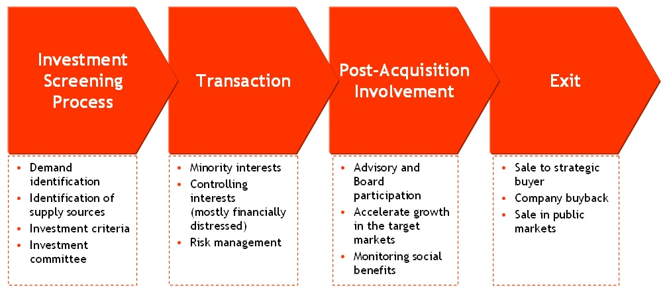
Scheme 1
Investment screening include the following:

Step 1. Analyze of the macroeconomic environment. Watch for macroeconomic events that can trigger fluctuations in individual sectors or the market as a whole.
Step 2. Watch for news stories on individual companies and industries. Expect active traders to react swiftly to news releases.
Step 3. Keep an eye on the legal environment. Watch for new laws and regulations, as well as orders from regulatory agencies, that can make or break companies and products.
Step 4. Understand emotional theory in the stock market. Economics textbooks teach you a wide range of financial decision-making models that apply to stock market investing, all of which rely upon the assumption that all traders act rationally after analyzing all pertinent information.
Step 5. Analyze and compare financial statements. Stock investors use companies' financial statements to assess their strength and performance compared to other players in their industry and the company's own previous data.

→ GLOSSARY

MARKET CAPITALIZATION is on-going market valuation of a public firm (whose shares are publicly traded) computed by multiplying the number of outstanding shares (held by the shareholders) with the current per share market price.

RISK PREMIUM – the return in excess of the risk-free rate of return that an investment is expected to yield. An asset's risk premium is a form of compensation for investors who tolerate the extra risk - compared to that of a risk-free asset - in a given investment.

PRINCIPAL-AGENT PROBLEM (conflicts of interest and moral hazard issues) that arise when a principal hires an agent to perform specific duties that are in the best interest of the principal but may be costly, or not in the best interests of the agent. The principal-agent problem develops when a principal creates an environment in which an agent has incentives to align its interests with those of the principal, typically through incentives. Principals create incentives for the agent to act as the principal wants because the principal faces information asymmetry and risk with regards to whether the agent has effectively completed a contract.

MUTUAL FUND is a company that pools money from many investors and invests the money in stocks, bonds, short-term money-market instruments, other securities or assets, or some combination of these investments. The combined holdings the mutual fund owns are known as its portfolio. Each share represents an investor's proportionate ownership of the fund's holdings and the income those holdings generate.

→ FORMULAS

A performance measure used to evaluate the efficiency of an investment or to compare the efficiency of a number of different investments. To calculate ROI, the benefit (return) of an investment is divided by the cost of the investment; the result is expressed as a percentage or a ratio. The return on investment formula:

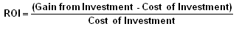

In the above formula "gains from investment", refers to the proceeds obtained from selling the investment of interest. Return on investment is a very popular metric because of its versatility and simplicity. That is, if an investment does not have a positive ROI, or if there are other opportunities with a higher ROI, then the investment should be not be undertaken.

→ QUIZZES AND EXERCISES

  - Find a right explanation for an advantages that a long-term investor has. There are several advantages:

1 = The ability to ride out short-term fluctuations in returns.
2 = Taking advantage of illiquid investment opportunities.
3 = Being able to profit from periods of elevated risk aversion or short-term mispricing.

Possible explanations are:

Asset returns are noisy in the short term. Furthermore, short-term volatility temporarily exacerbates liquidity needs, margin calls and funding issues, makes (operational) risk management more difficult, and frays the working relationships between managers, board members or trustees, the ultimate asset owners, and other stakeholders. Longrun investors have the luxury of knowing that there are no short-term funding issues or liabilities, and can earn risk premiums that often manifest reliably only over long periods. | A
In rational asset pricing models, prices are low because risk aversion is high and  investors bid down prices in order to receive high future expected returns. If a long2  horizon investor’s risk aversion remains constant, he can take advantage of these  periods with low prices. In behavioral models, prices can be low because of temporary periods of mispricing. Again, a long-horizon investor can take advantage of these times knowing that prices will return to fair values over the long run. | B
Clearly short-horizon investors cannot invest in illiquid investments if they wish to access capital before the illiquid investment can be realized. So, a long-horizon investor can take advantage of illiquid investment opportunities. | C

1.2. Look through the following articles and answer the question: Why do stock markets fluctuate?
Useful links:
http://beginnersinvest.about.com/cs/newinvestors/f/whystocksupdown.htm
Warren Buffett on Market Fluctuations: Investors Gain When the Market Falls || Available at: Value Investing Takes Advantage of Market Fluctuations|| Available at: http://www.getrichslowly.org/blog/2008/05/05/warren-buffett-on-market-fluctuations-investors-gain-when-the-market-falls/
http://www.cabot.net/value-investing/value-investing-and-market-fluctuations

1.3. Compare the Scheme 1,2 and 3. They demonstrate investment process. What are the basic principles of investment process? Draw up your own vision of investment process.

Scheme 2
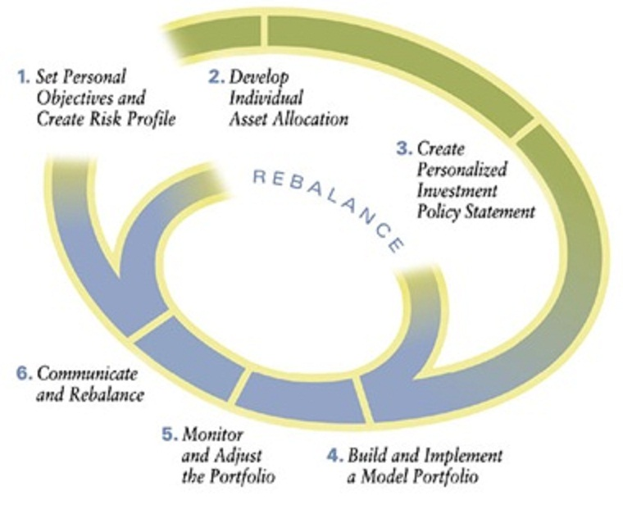

Scheme 3

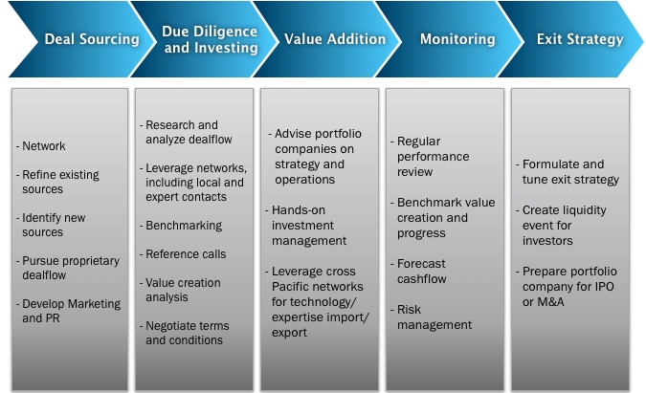

2. Fundamentals, valuations and analytical ratios (14 hours)
Basic assumptions: preferences, the expected utility hypothesis and investment period. Two-parameter (the expected return, risk) model of investor’s preferences. Forecasting techniques and trend analysis for long-term investments. Investment calculations. Value drivers. Financial statement analysis. Key classes of financial ratios. Discounted cash flow (DCF) analysis. Bond portfolios and re-investment risk.

→ KEY ISSUES (LECTURES)

2.1. There are several criteria to evaluate long-term investments. The first is Net present value (NPV). To calculate net present value you need to define the present value of cash flow streams and then – net investments. Another criteria are a payback period and internal rate of return.

2.2. Financial ratios help to get an express-analysis about the project or a company you are going to invest. There is a wide range of ratios, the most important are
- EARNUNG PER SHARE
- CURRENT RATIO
- PAYOUT RATIO
- PRICE/EARNINGS RATIO (P/E)
- PRICE TO SALES RATIO
- DEBT-EQUITY RATIO
- DIVIDEND YIELD
- PRICE-TO-BOOK VALUE RATIO

2.3. You can see the example of free cash flow calculating, based on cash flow statement of Omega Inc. To develop the Cash flow statement you also need data from Income statement and Balance sheet of a company.

Income Statement, Omega Inc. (in $th.)
 | Year 2010 | Year 2011 | Year 2012
Sales (revenue) | 500 | 550 | 575
– Cost of sales | (350) | (300) | (280)
– Depreciation | (10) | (10) | (20)
– General expenses | (40) | (45) | (55)
Earnings before interest and tax (EBTDA) | 100 | 195 | 220
– Interest expenses | (4) | (15) | (35)
Earnings before tax | 96 | 180 | 185
– Taxes (30%) | (32) | (54) | (55.5)
Net income | 64 | 126 | 130
– Dividends | (34) | (40) | (45)
Retained earnings | 30 | 86 | 85

Balance Sheet of Omega Inc. (in $th.)
Assets | Year 2010 | Year 2011 | Year 2012
Cash | 20 | 25 | 45
Accounts receivable | 50 | 70 | 100
Inventories | 100 | 110 | 110
Assets | 600 | 650 | 870
Total Assets | 770 | 855 | 1125
Liabilities | Year 2010 | Year 2011 | Year 2012
Accounts payable | 70 | 80 | 100
Bank debt | 50 | 75 | 150
Long-term debt | 150 | 200 | 375
Shareholder`s equity | 500 | 500 | 500
Total liabilities | 770 | 855 | 1125
Working capital* | 100 | 125 | 155

* Working capital = Cash + Accounts Receivable + Inventories – Accounts Payable

Free cash flow Statement, Omega Inc. (in $th.) |  |  |  | Source of data
 | Year 2010 | Year 2011 | Year 2012 | Source of data
Earnings before interest and tax (EBTDA) | 100 | 195 | 220 | Income Statement
– Tax paid on EBT | (32) | (54) | (55.5) | Income Statement
Net income without Debt | 68 | 141 | 164.5
+ Depreciation | (10) | (10) | (20) | Income Statement
+ Increase in Debt | 0 | 50 | 175 | Balance Sheet
– Increase in Fixed Assets | 0 | (50) | (220) | Balance Sheet
– Increase in Working Capital | 0 | (25) | (30) | Balance Sheet
Free cash flow | 58 | 106 | 69.5

Note the source of data in Free Cash flow statement. To know the Earnings and Taxes an income statement is used. The increase in Debt, Fixed Assets and Working Capital are calculated by a balance sheet data.

2.3. The procedure of evaluating the fair market price of investment include several steps (see Scheme 1).

Scheme 1

→ FORMULAS
The different cash flows methods start with the following expression:

Formula 1
$$V=\frac{{\text{CF}}_{1}}{1+k}+\frac{{\text{CF}}_{2}}{(1+k)^{2}}+\frac{{\text{CF}}_{3}}{(1+k)^{3}}+\text{.}\text{.}\text{.}+\frac{{\text{CF}}_{n}+{\text{VR}}_{n}}{(1+k)^{n}}$$

CF_{i} – cash flow generated by the company in the period I;
VR_{n} – residual value of the company in the year n;
K – appropriate discount rate for the cash flow`s risk.

There are several cash flows – the free cash flow, the equity cash flow, the capital cash flow and the debt cash flow. The free cash flow (FCF) enables to measure the total value of a company (V=E+D). The equity cash flow (ECF) is applied to measure the equity value of a company, and the debt cash flow enables to estimate the investment value of a debt.

To calculate free cash flows and total value of business by DCF-method you need formulas below:
${\text{FCFF}}_{t}=(\text{EBIT})∗(1−T)−(\text{CE}−D)−Δ\text{NCWC}$ Formula 2

FCFF – free cash flow to firm;
EBIT – earnings before interest and taxes;
CE – capital expenditures;
D – Depreciation;
∆NCWC – changes in non-cash working capital

$V_{\text{FCFF}}=\text{PV}+\frac{{\text{TV}}_{n+1}}{(1+\text{WACC})^{n}}$ Formula 3

V_{FCFF} – total value of business (E+D), measured by DCF-method;
PV – present value of future cash flows;
TV – terminal value of a firm;
WACC – weighted average cost of capital.

$\text{PV}=\sum_{t=1}^{n}{\frac{{\text{FCFF}}_{t}}{(1+{\text{WACC}}_{t})^{t}}}$ Formula 4

n – quantity of years in forecasting period.

$\text{TV}=\frac{{\text{FCFF}}_{n+1}}{\text{WACC}−g}$ Formula 5

g – growth rate of future free cash flows after the forecasting period.

Formula 6

K_{e} – cost of equity (required return to equity which reflects the equity`s risk);
K_{d} – cost of debt (required return to debt);
E – market value of the Equity;
D – market value of the Debts;
T – Tax rate.

To determine the cost of equity the Capital Asset Price Model can be applied (CAPM).

$k_{e}=R_{\text{fr}}+β×(R_{M}−R_{\text{fr}})$ Formula 7

K_{e} – cost of equity (required return to equity which reflects the equity`s risk);
R_{fr} – free risk Rate;
β – betta coefficient of publicly-traded shares of a Company;
R_{M}– rick-premium (average market rate of return).

To understand the valuation procedures see the following scheme 2.
Scheme 2
→ EXAMPLE

Let`s find the total value and equity value of Omega Inc., using the income-based approach and DCF-methods of valuation.

Step 1 /Historic and strategic analysis/

After analyzing the industry and its perspectives the following statements about the future business of Omega Inc. were made by an expert:
- The forecasting period is of 8 years and it includes the inertial period of 4 years and 4 years of investment program period;
- The first 4 years the sales` growth is of 2% because of the industry growth;
- The investment program of Omega Inc. during the following 4 years enables to increase the growth of sales by 12% every year and to decrease the share of cost of sales from 65% to 50%;
- The depreciation will increase from $th.20 to $th.50 in the investment period;
- The investment program is of $ th.400, and is to be financed by bonds issuing of $th.400 at a rate of 4% a year;
- The share of working capital is 27% and will be fixed during the forecasting period;
- The general expenses are growing at inflation rate (2%) during the forecasting period;
- The growth rate of flows of terminal value after the end of forecasting period is of 0%.
To calculate the discount rate the following adjustments were made:
  - The cost of Debt during the inertial period is 3.5%
  - The rick-premium (average market rate of return) 10%
  - Free-risk Rate 3%
  - β-coefficient 0.8

Step 2 /Projection of future cash flows/

The following projection of three statements was made on the basis of results of strategic and historic analysis. First of all the Income statement (see Scheme 2) and the Balance sheet (Scheme 3) were made for 8-years forecasting period.
Scheme 2
Scheme 3

Based on Income Statement and Balance Sheet the forecasting of free cash flows ( Formula ) were made (Scheme 4).

Scheme 4
Step 3 /Determination of cost of capital/

To calculate the discount rate (the weighted average cost of capital
CAPM-model were applied:

K_{e} = 3%+0.8 (10%-3%)= 8.4%

2013-2016:
K_{d} = 3.5% D/(E+D) = 0.43
K_{e} = 8.4% E/(E+D) = 0.57
$\text{WACC}=8\text{.}4\text{\%}×0\text{.}\text{57}+3\text{.}5\text{\%}×0\text{.}\text{43}×(1−0,3)$= 5.85 %

2017-2020:
$k_{D}=3\text{.}5\text{\%}×\frac{\text{375}}{\text{375}+\text{400}}+4\text{\%}×\frac{\text{400}}{\text{375}+\text{400}}=$3.76%
K_{d} = 3.5% D/(E+D) = 0.43
K_{e} = 8.4% E/(E+D) = 0.57
$\text{WACC}=8\text{.}4\text{\%}×0\text{.}\text{57}+3\text{.}5\text{\%}×0\text{.}\text{43}×(1−0,3)$= 4.89%

Step 4 /Calculation of the net present value of future cash flows and terminal value/
Scheme 52
Step 5 /Total value and Equity value of a Company/

The total value of Omega Inc. by income-based approach (DCF-method) is 4,866 $th

The equity value is calculated as

E = V –Net Debt, where Net Debt = Debt – Cash

4,866 – (375 – 45) = 4,536 $th

→ GLOSSARY

CASH FLOW – a revenue or expense stream that changes a cash account over a given period. Cash inflows usually arise from one of three activities - financing, operations or investing - although this also occurs as a result of donations or gifts in the case of personal finance. Cash outflows result from expenses or investments.

PRESENT VALUE – the current worth of a future sum of money or stream of CASH FLOWs given a specified rate of return.

DISCOUNTING – The process of determining the present value of a payment or a stream of payments that is to be received in the future. Discounting is the method used to figure out how much these future payments are worth today.

DISCOUNT RATE – The interest rate used in DISCOUNTed cash flow analysis to determine the present value of future cash flows. The discount rate takes into account the time value of money and the risk or uncertainty of the anticipated future CASH FLOWs.

EARNINGS PER SHARE (or EPS) is basically the profit that a company has made over the last year divided by how many shares are on the market.

PRICE/EARNINGS RATIO (P/E) is the best known of the investment valuation indicators. The P/E ratio has its imperfections, but it is nevertheless the most widely reported and used valuation by investment professionals and the investing public. A high P/E ratio means investors are paying more for today's earnings in anticipation of future earnings growth.

PRICE TO SALES RATIO measures the price of a company's stock against its annual sales, instead of earnings. Like the P/E ratio, the P/S reflects how many times investors are paying for every dollar of a company's sales.

DEBT-EQUITY RATIO is a leverage ratio that compares a company's total liabilities to its total shareholders' equity. This is a measurement of how much suppliers, lenders, creditors and obligors have committed to the company versus what the shareholders have committed. A lower number means that a company is using less leverage and has a stronger equity position. This ratio is not a pure measurement of a company's debt because it includes operational liabilities in total liabilities, nevertheless, this easy-to-calculate ratio provides a general indication of a company's equity-liability relationship

DIVIDEND YIELD is expressed as an annual percentage and is calculated as the company's annual cash dividend per share divided by the current price of the stock. The dividend yield is found in the stock quotes of dividend-paying companies. Investors should note that stock quotes record the per share dollar amount of a company's latest quarterly declared dividend.

PRICE-TO-BOOK VALUE RATIO expressed as a multiple (i.e. how many times a company's stock is trading per share compared to the company's book value per share), is an indication of how much shareholders are paying for the net assets of a company. "price-to-book", provides investors a way to compare the market value, or what they are paying for each share, to a conservative measure of the value of the firm.

PAYOUT RATIO tells how much profit goes out in dividends. This ratio identifies the percentage of earnings (net income) per common share allocated to paying cash dividends to shareholders. The dividend payout ratio is an indicator of how well earnings support the dividend payment.

CURRENT RATIO is used to test a company's liquidity (also referred to as its current or working capital position) by deriving the proportion of current assets available to cover current liabilities. The concept behind this ratio is to ascertain whether a company's short-term assets (cash, cash equivalents, marketable securities, receivables and inventory) are readily available to pay off its short-term liabilities (notes payable, current portion of term debt, payables, accrued expenses and taxes)

3. Managing portfolios for the long term
Investment horizon, likelihood of redemptions etc. Relevant asset price volatility, currency, fluctuating interest rates. Benefits/limitations of diversification. Active and passive strategies. Hedging and immunization. Risk-management. Leverage risks. Illiquidity risk. Key man risk issues.

3.1. Investment strategies consider the sources for investment profit – dividend payment and capital gain, measuring risks and all kind of fees, paid by investor. Investors fees include taxes, brokers and lawyers fees.

3.2. Growth investing is when you buy stocks (business) that expected to grow quickly in sales and earnings (relative to industry and market).There is no automatic formula for determining the best growth stocks. General guidelines for the strategy include: strong historical earnings growth
Strong forward earnings growth, Management control of costs and revenues, Company efficiency, Innovative products / industry.

3.3. Dividend investing considers investing in stocks (business) with a strong record of earnings and dividends. Because of the stock market volatility of recent years, many investors like the idea of a fund that offers them a regular payout.

3.4. Contrarian managers choose assets that are out of favor. They determine the market's consensus about a company or sector and then bet against it. The contrarian style is generally aligned with a value-investing strategy, which means buying assets that are undervalued by some statistical measure. The risk, of course, is that the consensus is right, which results in wrong bets and losses for a contrarian manager.

3.5. Strategy based on technical or fundamental analysis. Technical analysis involves choosing assets based on prior trading patterns. You're looking at the trends of an investment's price. Most managers emphasize fundamental analysis, because they want to understand what will drive growth. Investors expect the stock to rise if a company is growing profits, for example.

3.6. The principal-agent problem has been long studied in economics. It is a serious issue that impedes taking advantage of a long investment horizon and can lead to procyclical investments, the inability to generate value, and poor risk controls. Watch more about it here: http://www.youtube.com/watch?v=NfigWaPhAqo

Case Study ||
Solving The Principal Agent Problem: Apple Insists That Executives Must Hold Company Stock
Over the years there have been a number of attempts at solving the principal/agent problem. Apple‘s the latest to try and do so and it has to be said that their attempt is likely to avoid most of the problems of earlier ones.
Look the case study here:
http://www.forbes.com/sites/timworstall/2013/03/01/solving-the-principal-agent-problem-apple-insists-that-executives-must-hold-company-stock/

→ GLOSSARY

DIVERSIFICATION is an investing strategy that can be neatly summed up as "Don't put all your eggs in one basket." Spreading your investments across a wide range of companies and industry sectors can help lower your risk if a company or sector fails. Some investors find it easier to achieve diversification through ownership of mutual funds rather than through ownership of individual stocks or bonds.

PROFFESIONAL MONEY MANAGEMENT includes research, selection, and monitoring the performance of the purchased securities and businesses.

INVESTMENT HORIZON – is the total length of time that an investor expects to hold a security or portfolio. The investment horizon is used to determine the investor's income needs and desired risk exposure, which is then used to aid in security selection.

→ QUIZZES AND EXERCISES

3.1. Look through the following articles and find out the difference between active and passive investment strategy. Which suits you and why?

Useful links:

A Comparison of Active and Passive Investment Strategies || http://www.evansonasset.com/index.cfm?Page=2

Active vs passive investments
http://www.which.co.uk/money/savings-and-investments/guides/different-types-of-investment/active-vs-passive-investment/

3.2. Please choose from the list below what are the advantages for an active and passive strategy.
- Low fees
- Hedging opportunities
- Risk management
- Tax management
- Tax efficiency
- Good transparency

4. Venture investments and technological change
Value of intellectual property. Evaluating new ventures/startups. Should venture investments be held for the long term? Innovation, disruption and technological obsolescence.

4.1. Role of venture capital is crucial in a modern knowledge-based economy. Creativity and innovation are critical to the success of business, industry, and the economy. When ideas are developed into constructive goods and services and are protected through strong intellectual property (IP) rights, consumer interest and demand are spurred. As a result, jobs are created, economies grow, and societies advance.

Case Study ||
The impact of innovation and the role of intellectual property
US-industries example (00-07 period)

4.2. Venture investor is an investor who either provides capital to startup ventures or supports small companies that wish to expand but do not have access to public funding. Venture capitalists are willing to invest in such companies because they can earn a massive return on their investments if these companies are a success.

Case Study ||
What Return Do Venture Capitalists Expect?

A new venture can earn returns as high as 700 percent or have a negative return. According to the National Bureau of Economic Research, the average return is 25 percent. A venture capital firm will expect to at least make the average return but may have higher expectations, depending on the potential for business. A 25 percent return is higher than those other markets, so look at that percentage as a starting place for negotiations with venture capitalists. Venture capitalists expect to double their money - or even triple and quadruple it - over a period of several years. Venture capitalist Fred Wilson considers making 2.5 times his money in 10 years to be a successful investment, but he points out that some venture firms would consider such an investment a failure. Don't focus on the annual percentage you will pay to the exclusion of a multi-year return you can offer. You will have to factor in some growth to double or quadruple a venture capitalist's money over time.

4.3. It is important to know the stage of a new venture firm to make right venture investment decisions. The first stage is a seed stage of venture capital financing. Seed-stage financings are often comparatively modest amounts of capital provided to inventors or entrepreneurs to finance the early development of a new product or service. These early financings may be directed toward product development, market research, building a management team and developing a business plan. A genuine seed-stage company has usually not yet established commercial operations - a cash infusion to fund continued research and product development is essential.

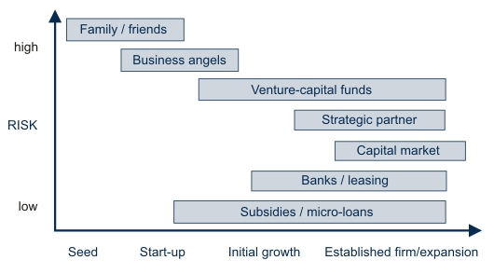
4.4. Early Stage - for companies that are able to begin operations but are not yet at the stage of commercial manufacturing and sales, early stage financing supports a step-up in capabilities. At this point, new business can consume vast amounts of cash; while VC firms with a large number of early-stage companies in their portfolios can see costs quickly escalate.

Start-up - Supports product development and initial marketing. Start-up financing provides funds to companies for product development and initial marketing. This type of financing is usually provided to companies just organized or to those that have been in business just a short time but have not yet sold their product in the marketplace. Generally, such firms have already assembled key management, prepared a business plan and made market studies. At this stage, the business is seeing its first revenues but has yet to show a profit. This is often where the enterprise brings in its first "outside" investors. First Stage - Capital is provided to initiate commercial manufacturing and sales. Most first-stage companies have been in business less than three years and have a product or service in testing or pilot production. In some cases, the product may be commercially available.

4.5. Formative Stage - Financing includes seed stage and early stage. Later Stage - Capital provided after commercial manufacturing and sales but before any initial public offering. The product or service is in production and is commercially available. The company demonstrates significant revenue growth, but may or may not be showing a profit. It has usually been in business for more than three years. Third Stage - Capital provided for major expansion such as physical plant expansion, product improvement and marketing. Expansion Stage - Financing refers to the second and third stages. Mezzanine (bridge) - Finances the step of going public and represents the bridge between expanding the company and the IPO

→ GLOSSARY

CAPITAL DILUTION – is a situation in which a shareholder's share of the profits of a company is reduced as a result of the company selling new shares.

ROUND OF INVESTMENT - the first major round of business financing by private equity investors or venture capitalists. In private equity investing, an "A" round, or Series A financing, is usually in the form of convertible preferred stock. An "A" round by external investors generally takes place after the founders have used their seed money to provide a "proof of concept" demonstrating that their business concept is a viable - and eventually profitable - one.

PREFERRED SHARES -

→ QUIZZES AND EXERCISES

4.1. A venture capitalist can invest $2 million in a new project that will last five years and will pay $18 million. His cost of equity for this project is 14%. He also knows that the project could fail at any time and has given the following percentages for the failure rate as follows:

Year 1: 35%, Year 2: 30%, Year 3: 25%, Year 4: 20%, Year 5: 20%

4.2. You invested in a start-up company. The total sum of investments was $1 million. Seven (7) years later you sold your share in a company for $5 million. What was your average annual return on investments?

4.3. Consider there is an investor who is going to invest $3,5 million The company is expected to earn $2,5 million in year five and should be comparable to companies with PRICE-to-EARNINGS Ratio of about 15. The venture capitalist expects to sell the company at that point. Assuming that the venture capitalist requires 50% projected internal rate of return (IRR). What price should he pay for the stock?

So venture capitalist must own enough share of the company in year five to realize 50% annual return on investment

5. Global challenges and investment long-term risks
Human capital and knowledge economy. Intellectual resources. Where are the jobs of the future? How will the world resolve the problems of too much debt? Public and private debt. Risks to debt holders. Risks of political and social unrest. Expectations regarding future returns to capital investment.

There are some important global trends that have to be considered in nowadays investment decisions. They are market bubbles, world debt crisis and knowledge-based economy.

5.1. Bubbles form in economies, securities, stock markets and business sectors because of a change in the way players conduct business. This can be a real change, as occurred in the bubble economy of Japan in the 1980s when banks were partially deregulated, or a paradigm shift, as happened during the dotcom boom in the late '90s and early 2000s. During the boom people bought tech stocks at high prices, believing they could sell them at a higher price until confidence was lost and a large market correction, or crash, occurs. Bubbles in equities markets and economies cause resources to be transferred to areas of rapid growth. At the end of a bubble, resources are moved again, causing prices to deflate. Thus, there is little long-term return on those assets.

Case Study ||
Dot-com bubble

Dot-com bubble (also referred to as the Internet bubble and the Information Technology Bubble) is a rapid rise in equity markets fueled by investments in internet-based companies. During the dotcom bubble of the late 1990s, the value of equity markets grew exponentially, with the technology-dominated Nasdaq index rising from under 1,000 to 5,000 between 1995 and 2000. Investors poured money into internet startups during the 1990s in the hope that those companies would one day become profitable. The collapse of the bubble took place during 2000-2001. Some companies, such as Pets.com, failed completely. Others lost a large portion of their market capitalization but remained stable and profitable, e.g., Cisco, whose stock declined by 86%. Some later recovered and surpassed their dot-com-bubble peaks, e.g., Amazon.com, whose stock went from 107 to 7 dollars per share.

5.2. Global debts have reached a record high despite efforts by governments to reduce public and private borrowings. When we discuss debt problems, we often hear these terms. There are two types of inability to repay.
Insolvency means the borrower (or the borrowing country) is unable to pay back, both today and in the future. It has spent money beyond its inter-temporal budget constraint, so there is no way they can service the debt in full, even if they try. In this case, waiting does not improve the situation. The lenders must face the inevitable result that some (or even all) of the money will not be repaid. The only solution is forgiving debt--give up the hope of full repayment.
Illiquidity means the borrower (or the borrowing country) is unable to pay back now, but it can pay back later. It just does not have enough cash in the pocket (or not enough international reserves in the central bank), but it expects future income or export receipts so debt will be fully serviced (with added interest for late payment) in the future. In this case, the appropriate response is delaying the repayment, or "debt rescheduling."

Case Study ||
What is the scale of a global debt

The amount of debt globally has soared more than 40 percent to $100 trillion since the first signs of the financial crisis as governments borrowed to pull their economies out of recession and companies took advantage of record low interest rates, according to the Bank for International Settlements. The $30 trillion increase from $70 trillion between mid-2007 and mid-2013 compares with a $3.86 trillion decline in the value of equities to $53.8 trillion in the same period, according to data compiled by Bloomberg. The jump in debt as measured by the Basel, Switzerland-based BIS in its quarterly review is almost twice the U.S.’s gross domestic product.

5.3. The world economy is changing at an unprecedented rate. The forces of globalization and technological progress are altering the way that people all over the planet make a living.
Some countries, especially in the emerging world, are using this wave of change to drive
rapid growth in their economies.

Case Study ||
What are the opportunities of knowledge-based economy

Business thinkers gathered at the World Economic Forum earlier this year talked at length about the rapid proliferation of “disruptive technologies” that are challenging the sustainability of many traditional business models and making the future course of global commerce impossible to predict. When you consider that Apple and Google – attracting a market cap of $509-billion (U.S.) and $356-billion respectively – now tower over traditional corporate giants such as Exxon ($434-billion) and General Electric ($267-billion) in value, a little worried chatter and hand-wringing is understandable.

LITERATURE

Main literature:
1) Gibson R. C. Asset allocation. – McGraw-Hill Education, 2013.
2) Brealey R., Myers S., Allen F. Principles of Corporate Finance [Text] / Richard A. Brealey, Stewart C. Myers., Franklin Allen. – McGraw-Hill, 2008. – 1044 p.
4) Cochrane J.H. Asset pricing (Revised) [Text] / John H. Cochrane. – Princeton University Press, 2005. – 568 p.
5) Damodaran A. Investment valuation: Tools and techniques for determining the value of any asset. – John Wiley & Sons, 2012.
6) Haugen R. A., Haugen R. A. Modern investment theory. – Prentice Hall, 1990. – Т. 5.
7) Koller T. et al. Valuation: measuring and managing the value of companies. – John Wiley and Sons, 2010. – Т. 499.
8) Lerner J., Hardymon G. F., Leamon A. Venture capital and private equity: A casebook. – New York : Wiley, 2002. – С. 63.
9) Metrick A., Yasuda A. Venture capital and the finance of innovation. – Hoboken, NJ : Wiley, 2007.
10) Tigue J. The Standard & Poor's Guide to Building Wealth with Dividend Stocks. – McGraw Hill Professional, 2006.

Additional literature:
1) Bodie Z., Kane A., Marcus A.J. Essentials of Investment. 5th edition [Text] / Zvi Bodie, Alex Kane, Alan J. Marcus. Essentials of Investment – McGraw Hill Irwin, New York – 2002. – 994 p.
2) Von Neumann J., Morgenstern O. Theory of games and economic behavior. 60th anniversary commemorative edition [Text] / John von Neumann, Oskar Morgenstern. – Princeton University Press, 2007. – 776 p.
3) Weber B., Alfen H. W. Infrastructure as an asset class: Investment Strategies, Project Finance and PPP. – John Wiley & Sons, 2010.
4) Fraser-Sampson G. Multi asset class investment strategy. – John Wiley & Sons, 2006.
5) Ang A., Kjaer K. Investing for the long run //A Decade of Challenges: A Collection of Essays on Pensions and Investments. Andra AP-fonden, Second Swedish National Pension Fund-AP2. – 2011.

Internet resources
1) Official site of the Board of Governors of the Federal Reserve System. The access mode: http://federalreserve.gov/.
2) Official site of the Moscow Exchange. The access mode: http://moex.com/.
3) Official site of the New York Stock Exchange. The access mode: http://nyse.com/.
4) Official site of the National Association of Securities Dealers Automated Quotation (NASDAQ). The access mode: http://www.nasdaq.com/.
5) Мarket information portal. Project investfunds.ru/: http://www.investfunds.ru/.

