Ministry of Education and Science of the Russian Federation
State Educational Institution of Higher Professional Education

Lobachevsky State University of Nizhni Novgorod -
National Research University

Faculty for International Students

MANUAL of the course

FINANCIAL AND CREDIT RISK MANAGEMENT

Area of Studies
38.04.02. Management

Profile of training with instruction in English
Economics and Management of Financial Institutions

Qualification (degree) of graduates
Master

Form of training
full-time

Nizhni Novgorod
2014

Contents

MANUAL of the course 1
LEARNING GOALS AND OBJECTIVES FOR THE COURSE 3
THE STRUCTURE AND CONTENT OF THE COURSE 4
Structure of the course 4
Content of the course 4
WORKBOOK 5
1. Introduction to risk-management 5
2. Credit risk assessment 8
3. Market risk assessment 13
4. Managing a risk in a corporate 16
5. Venture risks 18
6. Global challenges and risks 21
LITERATURE 22
Main literature: 22
Additional literature: 22
Internet resources 22

LEARNING GOALS AND OBJECTIVES FOR THE COURSE

This course aims to provide students with an understanding of different types of risks the financial institutions are exposed to. The course is designed to address the many types of risks, focusing on the available methods for measuring the risks and managing them. As a result students should be able to implement some econometric methods to evaluate and manage those risks. In addition the course will develop analytical skills in risk modeling.
When have completed the course student will be able to:
- identify specific types of risks, their reasons, drivers and impact on investment and financial decision;
- implement some techniques and statistic analysis for evaluating the risk;
- calculate the available risk level;
- outline expenses charged by different types of strategic investments;
- explain the accounting principles for investments deals;
- describe different financial strategies and policies that an investor must address;
- identify different types of mergers and acquisition deals;
- describe problems with performance evaluation of investment project;
- evaluate the risk profile of a long-term investment and describe the constraints faced by investors;
- choose a list of value-based drivers based on an investment plan;
- comment on when different types of financing are appropriate for a long-term investment;
- explain how the main principles of long-term investments have changed in a knowledge-based economy.
The main tasks of the discipline are the following:
- to explain the basic principles of financial risk management;
- to survey the empirical methods of managing the credit risk;
- to teach students how to use a set of techniques for measuring the risk;
- to develop students’ experimental and analytical skills;
- to explain the consequences of global financial crisis.

THE STRUCTURE AND CONTENT OF THE COURSE
The overall workload of the course is 3 credits, 108 hours.

Structure of the course
Name оf the course | Semester | Workload (hours) |  |  |  |  |  | Type of  final certification
Name оf the course | Semester | Total | Total class  room | Including classroom |  |  | Self-organized work | Type of  final certification
 |  |  |  | Lectures | Lab./seminars | Practice | Self-organized work | Type of  final certification
Financial and credit risk management | 3 | 108 | 60 | 24 | 0 | 36 | 18 | Pass\Failed

Content of the course
Part 1. Introduction to risk-management (12 hours)
Decision-making under risk. Volatility risk. Interest rate risk. Credit risk. Market risk. Liquidity Risk.

Part 2. Credit risk assessment (6 hours)
Distinguishing credit risk from market risk. Credit policy and credit risk. Credit risk assessment framework. Inputs to credit models.

Part 3. Market risk assessment (8 hours)
Risk metrics. Value-at-risk technology.
Basics for a computer modeling of financial risks.
Application equity and Forex markets. Derivatives.

Part 4. Managing risk in a corporate (12 hours)
Risk-management process. Leverage risks. Illiquidity risk. Key man risk issues.
Methods of risk-management.

Part 5. Venture risks (12 hours)
Risks in a venture projects. Principles of risk-management in a start-up company.

Part 6. Global challenges and risks (6 hours)
Global Financial crises and their consequences. Extreme risk events.

WORKBOOK

1. Introduction to risk-management
Decision-making under risk. Volatility risk. Interest rate risk. Credit risk. Market risk. Liquidity Risk.

→ USEFUL LINKS AND INFORMATION SOURCES

- ISO 31000. Risk-management ISO
- COSO Committee of Sponsoring Organizations, Enterprise Risk Management—Integrated Framework (2004), p. 4.

→ KEY ISSUES (LECTURES)

  - Since the 1990s risk-management has undergone a dramatic expansion in its reach and significance, being transformed from an aspect of management control to become a benchmark of good governance for banks, hospitals, schools, charities, and many other organizations. Numerous standards for risk management practice have been produced by a variety of transnational organizations. Risk management has created new demands for proof and evidence of action. In turn, these demands have generated new risks to reputation.

Risk innovations set off a revolution in the financial service industry.

Case Study ||
Risk-management – serious impact on financial sector

As soon as risk management instruments became available, many investors wanted to take advantage of them. Thus private equity and hedge funds began to attract more capital. 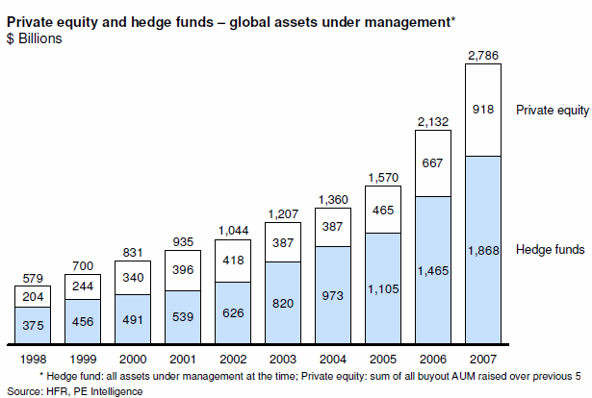

Case Study ||
Goldman Sachs – risks money to make money

Goldman Sachs is the worlds leading investment banking, securities and investments management firm. It exploits risk to achieve attractive returns in a prudent fashion. The results are great. During the financial turmoil of 2007-08 this company avoided the large losses that afflicted its main competitors, perhaps the strongest evidence that its risk-based culture creates superior performance.

«People who have let Goldman say its risk management is unmatched at rivals. One consequence is that Goldman seems confident that it can take more risks than its competitors do. Its trading revenues are the most volatile among big investment banks and it has the most days when it loses money. Overall, however it makes the most money».

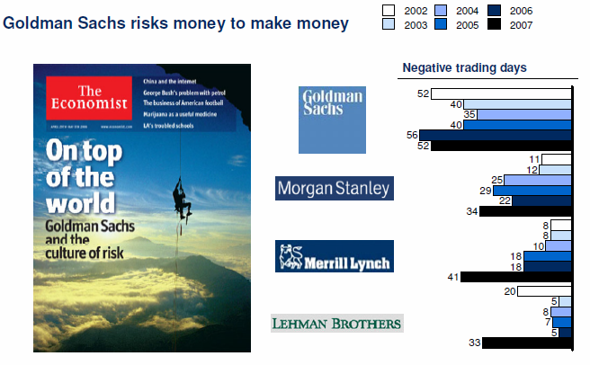
Sources: The Economist 2006, Moodys, SNL Financial.

  - There are different approaches to the definition of risk-management. Risks can come from uncertainty in financial markets, threats from project failures (at any phase in design, development, production, or sustainment life-cycles), legal liabilities, credit risk, accidents, natural causes and disasters as well as deliberate attack from an adversary, or events of uncertain or unpredictable root-cause.

  - The main goal of risk management is to create a value to the owners.

  - Methods, definitions and goals vary widely according to whether the risk management method is in the context of project management, security, engineering, industrial processes, financial portfolios, actuarial assessments, or public health and safety.

  - There are a lot of different types of risks. It depends on the approach – what type of risks do you assess and manage. Financial and credit risks are in the focus of everyday companies management. Sometimes financial risks are considered the same as market risks. In the past, managing the credit portfolio was considered good risk management. But in today's broader, more complex environment, best-practice institutions understand that they need to measure and manage risk across the entire enterprise.

  - Enterprise risk management (ERM) is the capability of an organization to understand, control, and articulate the nature and level of the risks taken in pursuit of a risk adjusted return. The risks can be categorized as Credit, Liquidity, Strategic / Business / Reputation, Market, Operational, Compliance / Legal, Financial, and Capital Adequacy.

  - Operational risks exist in every financial organization, regardless of its size, in any number of forms including hurricanes, blackouts, computer hacking, and organized fraud. Managing those risks—however big or small—is critical to an organization’s success. The way operational risks are being managed is depend on the sector, product and process markets of the enterprise.

  - Risk management is the process of minimizing or mitigating the risk. It starts with the identification and evaluation of risk followed by optimal use of resources to monitor and minimize the same.

→ GLOSSARY

Enterprise risk management (ERM) is a framework to reduce earnings volatility through a robust risk governance structure and strong risk culture, supported by sound risk management capabilities.

Liquidity risk is that a given security or asset cannot be traded quickly enough in the market to prevent a loss (or make the required profit).

Volatility risk is a of a change of price of a portfolio as a result of changes in the volatility of a risk factor. It usually applies to portfolios of derivatives instruments, where the volatility of its underlyings is a major influencer of prices.

Credit risk refers to the risk that a borrower will default on any type of debt by failing to make required payments.

Market risk is a is the risk of losses in positions arising from movements in market prices (including prices on financial instruments, currencies, shares and derivatives and etc.)

→ FORMULAS

Key formula says that

RISK = Negative IMPACT to objectives X LIKELIHOOD of occurrence.

→ QUIZZES AND EXERCISES

Ex.1.1. See the introduction materials in recommended literature and try to explain what the difference between risk and uncertainty?

Ex.1.2. Look through the ISO 31000 Risk-management ISO (definitions and 11 principles) аnd fill in the gap in a following statement.

Risk is the effect of the on objectives.
Good risk management contributes and protect the _______ of the company (main goal).
Ex.1.3. Using a business dictionary (surf the Internet) give the following definitions.

Risk management is a process, that …
Risk assessment is a process, that …
Risk metrics are …

Ex.1.4. Using a business dictionary (surf the Internet) give the practice equivalents of the following types of risks.

Market risks include
Business risks include
Financial risks include
Credit risks include

Ex.1.5*
Compare COSO and ISO (see main information sources) main issues covering risk management process in organization. Propose your method of comparison of results.

2. Credit risk assessment
Distinguishing credit risk from market risk. Credit policy and credit risk. Credit risk assessment framework. Inputs to credit models.

→ KEY ISSUES (LECTURES)

2.1. There are two main types of credit risk:
- Credit spread risk: Credit spread risk is exhibited by portfolios for which the credit spread is traded and marked-to-market. Changes in observed credit spreads impact the value of these portfolios.
- Credit default risk: All portfolios of exposures exhibit credit default risk, as the default of an obligor results in a loss.

2.2 Credit spread is the excess return demanded by the market for assuming a certain credit exposure. Credit spread risk is the risk of financial loss owing to changes in the level of credit spreads used in the marked-to-market of a product.
Credit spread risk fits more naturally within a market risk management framework. In order to manage credit spread risk, a firm’s value-at-risk model should take account of value changes caused by the volatility of credit spreads. Since the distribution of credit spreads may not be normal, a standard variance-covariance approach to measuring credit spread risk may be inappropriate. However, the historical simulation approach, which does not make any assumptions about the underlying distribution, used in combination with other techniques, provides a suitable alternative.
Credit spread risk is only exhibited when a mark-to-market accounting policy is applied, such as for portfolios of bonds and credit derivatives. In practice, some types of products, such as corporate or retail loans, are typically accounted for on an accruals basis. A mark-to-market accounting policy would have to be applied to these products in order to recognize the credit spread risk.

2.3. Credit default risk is the risk that an obligor is unable to meet its financial obligations. In the event of a default of an obligor, a firm generally incurs a loss equal to the amount owed by the obligor less a recovery amount which the firm recovers as a result of foreclosure, liquidation or restructuring of the defaulted obligor.
All portfolios of exposures exhibit credit default risk, as the default of an obligor results in a loss. Credit default risk is typically associated with exposures that are more likely to be held to maturity, such as corporate and retail loans and exposures arising from derivative portfolios. Bond markets are generally more liquid than loan markets and therefore bond positions can be adjusted over a shorter time frame. However, where the intention is to maintain a bond portfolio over a longer time frame, even though the individual constituents of the portfolio may change, it is equally important to measure the default risk that is taken by holding the portfolio.

2.4. There are two credit products that can produce credit risks: loans and bonds.

Loans
- May be secured with either collateral or payment guarantees to ensure a reliable source of secondary repayment in case the borrower defaults
- Often written with covenants that require the loan to be repaid immediately if certain adverse conditions exist, such as a drop in income or capital
- Generally reside in the bank’s banking book or credit portfolio
- Although banks may sell loans another bank or entity investing in loans

Bonds
- Collateral support, payment guarantees, or secondary sources of repayment may all support certain types of bonds
- Structuring characteristics that determine a bond investor’s potential recovery in default
- Generally reside in the bank’s trading book

2.5. When managing credit risk, there are several measures of risk that are of interest, including the following:
• Distribution of loss: The risk manager is interested in obtaining distributions of loss that may arise from the current portfolio. The risk manager needs to answer questions such as “What is the size of loss for a given confidence level?”.
• Identifying extreme outcomes: The risk manager is also concerned with identifying extreme or catastrophic outcomes. These outcomes are usually difficult to model statistically but can be addressed through the use of scenario analysis and concentration limits.

2.6. Credit risk can be managed through diversification because the number of individual risks in a portfolio of exposures is usually large.
Currently, the primary technique for controlling credit risk is the use of limit systems, including individual obligor limits to control the size of exposure, tenor limits to control the maximum maturity of exposures to obligors, rating exposure limits to control the amount of exposure to obligors of certain credit ratings, and concentration limits to control concentrations within countries and industry sectors.
The portfolio risk of a particular exposure is determined by four factors: (i) the size of the exposure, (ii) the maturity of the exposure, (iii) the probability of default of the obligor, and (iv) the systematic or concentration risk of the obligor. Credit limits aim to control risk arising from each of these factors individually. The general effect of this approach, when applied in a well-structured and consistent manner, is to create reasonably well-diversified portfolios. However, these limits do not provide a measure of the diversification and concentration of a portfolio.
In order to manage effectively a portfolio of exposures, a means of measuring diversification and concentration has to be developed. An approach that incorporates size, maturity, credit quality and systematic risk into a single portfolio measure is required.

2.7. A key decision that has to be made when modeling credit risk is the choice of time horizon. Generally, the time horizon chosen should not be shorter than the time frame over which risk-mitigating actions can be taken.
It does not prescribe any one particular time horizon but suggests two possible time horizons that can provide management information relevant for credit risk management:
• A constant time horizon, such as one year.
• A hold-to-maturity or run-off time horizon.
2.8. Any modeling of credit risk is dependent on certain data requirements being met. The quality of this data will directly affect the accuracy of the measurement of credit risk and therefore any decision to be made using the results should be made only having fully assessed the potential error from uncertainties in the data used.`

2.9. Generally, current accounting and provisioning policies recognise credit income and credit losses at different times, even though the two events are related. Usually, credit loss provisions are made only when exposures have been identified as non-performing. These provisions are often supplemented with other specific and general credit provisions.
In relation to any portfolio of credit exposures, there is a statistical likelihood that credit default losses will occur, even though the obligors are currently performing and it is not possible to identify specifically which obligors will default. The level of expected loss reflects the continuing credit risk associated with the firm’s existing performing portfolio and is one of the costs of doing credit-related business. This level of expected loss should be taken account of when executing any business that has a credit risk impact.
When default losses are modeled, it can be observed that the most frequent loss amount will be much lower than the average, because, occasionally, extremely large losses are suffered, which have the effect of increasing the average loss. Therefore, a credit provision is required as a means of protecting against distributing excess profits earned during the below average loss years.

→ GLOSSARY

There are several common measures to estimate the credit risk

Probability of default - the likelihood that the borrower will fail to make full and timely repayment of its financial obligations

Exposure At Default (EAD) - the expected value of the loan at the time of default

Loss Given Default (LGD) - the amount of the loss if there is a default, expressed as a percentage of the EAD

Recovery Rate (RR) – the proportion of the EAD the bank recovers

There are two credit products that can produce credit risks. They are

Loan - a contractual agreement that outlines the payment obligation from the borrower to the bank.

Bond - a publicly traded loan — an agreement between the issuer and the purchasers

→ FORMULAS

Ex.1 Estimating Expected Losses

The most basic model of expected loss considers two outcomes: default and non-default
In the event of non-default the credit loss is 0.
In the event of default, the loss is loss given default (LGD) times the current exposure (EAD), thus

(2.1)

Ex.2 Credit Risk + Model (estimating unexpected losses)

Credit defaults occur as a sequence of events in such a way that it is not possible to forecast the exact time of occurrence of any one default or the exact total number of defaults. In this section we derive the basic statistical theory of such processes in the context of credit default risk. Consider a portfolio consisting of N obligors. In line with the above assumptions, it is assumed that each exposure has a definite known probability of defaulting over a one-year time horizon. Thus

(2.2)

To analyze the distribution of losses from the whole portfolio, we introduce the probability generating function defined in terms of an auxiliary variable z by

An individual obligor either defaults or does not default. The probability generating function for a single obligor is easy to compute explicitly as
(2.3)
As a consequence of independence between default events, the probability generating function for the whole portfolio is the product of the individual probability generating functions. Therefore
It is convenient to write this in the form

Suppose next that the individual probabilities of default are uniformly small. This is characteristic of portfolios of credit exposures. Given that the probabilities of default are small, powers of those probabilities can be ignored. Thus, the logarithms can be replaced using the expression
and, in the limit, equation this equation becomes

where we write
for the expected number of default events in one year from the whole portfolio.
To identify the distribution corresponding to this probability generating function, we expand F(z) in its Taylor series:
Thus if the probabilities of individual default are small, although not necessarily equal, then from equation we deduce that the probability of realising n default events in the portfolio in one year is given by
(2.4)

→ QUIZZES AND EXERCISES

Ex.2.1 Please fill the gaps in the following text

Title: Credit Risk vs Market Risk

Market risk is the potential ________ due to changes in market ________ or values
• Assessment time horizon: typically one _______

Credit risk is the potential loss due to the nonperformance of a financial contract, or
financial aspects of nonperformance in any contract

• Assessment time horizon: typically one _______

_________ risk is generally more important than _______ risk for banks

Many credit risk drivers relate to market risk drivers, such as the impact of market conditions on default probabilities.

Differs from market risk due to obligor behavior considerations
The five “C’s” of Credit — Capacity, Conditions, Collateral, Character and __________

Both credit and market risk models use historical data, forward looking models and ________ models to assess risks

3. Market risk assessment
Risk metrics. Value-at-risk technology. Basics for a computer modeling of financial risks. Application equity and Forex markets. Derivatives.

→ LECTURE MATERIALS

3.1. Market risk refers to the risk of losses due to changes in equity prices, interest rates, credit spreads, foreign-exchange rates, commodity prices, and other indicators whose values are set in a public market. To manage market risk, banks and investment companies deploy a number of highly sophisticated mathematical and statistical techniques. Chief among these is value-at-risk (VAR) analysis, which over the past 15 years has become established as the industry and regulatory standard in measuring market risk.

3.2. Market Risk is also referred to as systematic risk or non-diversifiable risk. Market risk is comprised of the “unknown unknowns” that occur as a result of everyday life. It is unavoidable in all risky investments. It can also be thought of as the opportunity cost of putting money at risk.

3.3. The most basic strategy for minimizing market risk is diversification. A well-diversified portfolio consists of securities from various industries, asset classes and countries with varying degrees of risk. The specific risks will offset each other but some market risk will always remain. Because of market efficiency, you will not be compensated for the additional risks that arise from failure to diversify your portfolio. This is extremely important for those who may have a large holding of one stock as part of an employer-sponsored incentive plan. Specific risk exposes you to adverse events on a company or industry level in addition to adverse events on a global, economic level.

3.4. The sources for market risk are different. Market risk often arises from other forms of financial risk such as credit and market liquidity risks. For example, a downgrading of the credit standing of an issuer could lead to a drop in the market value of securities issued by that issuer. Likewise, a major sale of a relatively illiquid security by another holder of the same security could depress the price of the security.
The institution should also take into account the general market and macroeconomic conditions in which it operates in its assessment and management of risks and its loss absorbing capacity. It should ensure that its risk processes and capital levels are adequate for countering the impact of potential stress developments, including significant deterioration of market liquidity conditions, which emanate from its operating environment.

3.5. Risk metrics include the following – volatility, duration, value-at-risk and beta. All these metrics are based on historical data and some calculations.

Case Study ||
How to calculate a value-at-risk

You are a USD-based corporation and hold a DEM 140 million FX position. What is your VaR over a 1-day horizon given that there is a 5% chance that the realized loss will be greater than what VaR projected? The choice of the 5% probability is discretionary and differs across institutions using the VaR framework.

What is your exposure?

The first step in the calculation is to compute your exposure to market risk (i.e., mark-to-market your position). As a USD based investor, your exposure is equal to the market value of the position in your base currency. If the foreign exchange rate is 1.40 DEM/USD, the market value of the position is USD 100 million.

What is your risk?

Moving from exposure to risk requires an estimate of how much the exchange rate can potentially move. The standard deviation of the return on the DEM/USD exchange rate, measured historically can provide an indication of the size of rate movements. In this example, we calculated the DEM/USD daily standard deviation to be 0.565%. Now, under the standard RiskMetrics assumption that standardized returns ( on DEM/USD are normally distributed given the value of this standard deviation, VaR is given by 1.65 times the standard deviation (that is, 1.65 σ) or 0.932%. This means that the DEM/USD exchange rate is not expected to drop more than 0.932%, 95% of the time. RiskMetrics provides users with the VaR statistics 1.65 σ.

In USD, the VaR of the position1 is equal to the market value of the position times the estimated volatility or:

FX Risk: $100 million x 0.932% = $932,000

What this number means is that 95% of the time, you will not lose more than $932,000 over the next 24 hours.

Case Study ||
What does duration mean?

The idea behind duration is simple. Suppose a portfolio has a duration of 3 years. Then that portfolio’s value will fall about 3% for each 1% rise in interest rates—or rise about 3% for each 1% decline in interest rates. Such a portfolio is less risky than one which has a 10-year duration. That portfolio is going to decline in value about 10% for each 1% rise in interest rates. Convexity provides additional risk information.

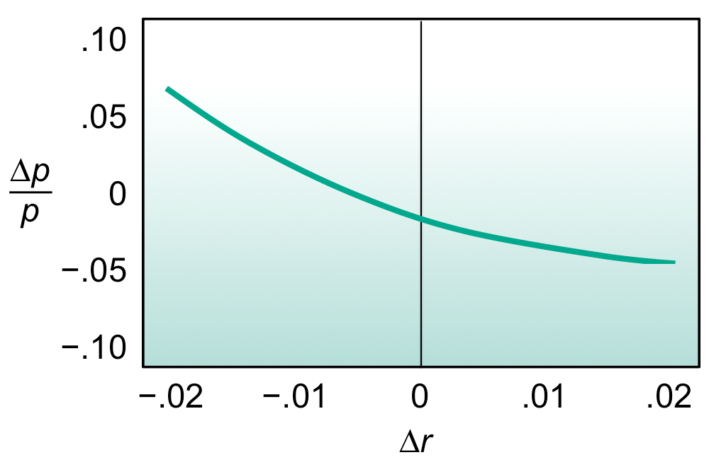
Here, Δr represents an immediate parallel shift in interest rates. For example, Δr = .015 corresponds to a 1.5% (or 150 basis point) parallel rise in the spot curve. The variable Δp is the dollar change in the portfolio’s value resulting from the shift in interest rates. Accordingly, Δp/p is the fractional change in the portfolio’s value.
Exhibit fully describes the portfolio’s sensitivity to parallel shifts in the spot curve. There is no more information that we could add to the picture. What we try to do with duration and convexity is summarize the entire picture of Exhibit with just two numbers. Certainly, two numbers cannot describe the wealth of detail contained in a picture, so what we do is take the two most important pieces of information in the picture. Those two pieces of information are duration and convexity.

→ GLOSSARY

There are different types of risk metrics

Volatility – is a measure for variation of price of a financial instrument over time, corresponded to a standard deviation.

Beta describes the sensitivity of an instrument or portfolio to broad market movements. Beta is a risk metric employed primarily in the equity markets. It measures the systematic risk of a single instrument or an entire portfolio. William Sharpe (1964) first used the notion in his landmark paper introducing the capital asset pricing model (CAPM). The name “beta” was applied later.

Duration of a financial asset that consists of fixed cash flows, for example a bond, is the weighted average of the times until those fixed cash flows are received. When an asset is considered as a function of yield, duration also measures the price sensitivity to yield, the rate of change of price with respect to yield or the percentage change in price for a parallel shift in yields.

Value-at-Risk is a measure of the maximum potential change in value of a portfolio of financial instruments with a given probability over a pre-set horizon. VaR answers the question: how much can I lose with x% probability over a given time horizon.

→ FORMULAS

3.1. To measure a beta under CAPM (W.Sharp) you may use the following formula:

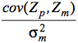 (3.1)
where
cov(Z_{p},Z_{m}) is the covariance between the portfolio (or instrument) return and the market return, and
is the variance of the market’s return (volatility squared).

3.2. Macaulay duration, named for Frederick Macaulay who introduced the concept, is the weighted average maturity of cash flows. Consider some set of fixed cash flows. The present value of these cash flows is:
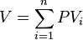
Macaulay duration is defined as
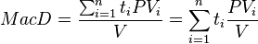 (3.2)
where:
- indexes the cash flows,
- is the present value of the th cash payment from an asset,
- is the time in years until the th payment will be received,
- is the present value of all future cash payments from the asset.

3.3. Standard deviation (volatility) can be defined as follows
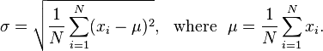 (3.3)

→ QUIZZES AND EXERCISES

Ex.3.1 Explain what is the difference between risk measures and risk metrics?

See at: http://www.riskglossary.com/link/risk_metric_and_risk_measure.htm to have a right answer.

Ex.3.2 Indicate what is true and what is false?

True | false | Beta is used as a metric of a portfolio’s market risk. This can be misleading because beta does not capture specific risk.
True | false | Because of specific risk, a portfolio can have a low beta but still be highly volatile. Its price fluctuations will simply have a high correlation with those of the overall market.
True | false | Market risk is also reffered to as a non-systematic, diversified risk.

Ex.3.3 Indicate what is true and what is false?

You are a USD-based corporation and hold a DEM 140 million position in the 10-year German government bond. What is your VaR over a 1-day horizon period, again, given that there is a 5% chance of understating the realized loss and bond standard deviation is of 0.605%.

Note: The only difference versus the example in case study is that you now have both interest rate risk on the bond and FX risk resulting from the DEM exposure. The exposure is still USD 100 million but it is now at risk to two market risk factors. Now, the total risk of the bond is not simply the sum of the interest rate and FX risk because the correlation2 between the return on the DEM/USD exchange rate the return on the 10-year German bond is relevant. In this case, we estimated the correlation between the returns on the DEM/USD exchange rate and the 10-year German government bond to be -0.27.

4. Managing a risk in a corporate
Enterprise risk-management (ERM) process. Leverage risks. Illiquidity risk. Key man risk issues. Methods of risk-management.

→ KEY ISSUES (LECTURES)

4.1 ERM provides a framework for risk management, which typically involves identifying particular events or circumstances relevant to the organization's objectives (risks and opportunities), assessing them in terms of likelihood and magnitude of impact, determining a response strategy, and monitoring progress.

4.2. Usually ERM framework consists of steps following one by one. These are risk identification, risk assessment, risk analysis, implementation, monitoring, evaluation. The set of methods and practices, implemented on every step of ERM, can be defined as risk policy of a company.
Every institution should formulate risk policies which should be approved by its Board of Directors or high-management staff. These policies, which should be reviewed periodically, should reflect the strategy and processes of the institution, including its approach to controlling and managing risks.

4.3. The identification process in ERM includes the following: taking inventory of all risks and defining the potential risk event, the causes to that risk event and the potential outcome if that risk event were to occur. This process depends on the types of risks that a company is going to manage. Usually these are project (or strategic), credit and financial (market) risks and operational risks. To arrange all risks in a system a 4-scope SWOT analysis and other matrix methods are used.

Case Study ||
Use of matrixes in a risk analysis

There are various suggested matrixes to discuss and measure identified risks. A matrix may be helpful in structuring risks and prioritizing risks management by giving a numerical value to the risk. Please be aware of that the use of a matrix may lead to biased assumptions depending on who discusses them. It should not be used in an absolute manner, but rather as a tool for discussion. A risk matrix may include:
Probability: Answering the question: What is the probability that a risk to the project will occur?
Danger: Answering the question: How much will the risk affect the success, or the implementation of the program or project?
Risk management: All actions or activities that are aimed at avoiding or mitigating the risk
Monitoring: Adopted measures or actions should be monitored and improved.
Evaluation: To assess whether the actions were efficient

4.4. The risk assessment means determining the cause of the risk event, its impact and velocity. Not all risks can be measured, using quantitative methods. But usually all financial and credit risks can be assessed like that. It is important to find out the roots, that causes the risk. They are physical, human and organization causes. There is a wide rang of methods to assess different types of risks.

4.5. Risk analysis includes understanding, determining and formulating the risks. Data analysis is the key issue in the process of risk analysis. It uses both analytical and logic skills. When assessing risks it is important to define if it is an internal or external risk.

Case Study ||
Some examples of internal risks and guiding questions to discuss them

a) Corruption may be the most common risk to take into consideration. Corruption is understood as the abuse of power by acts that generate illegal profit either by a person or a group, which seriously affect legitimacy, confidence and trust among partners and prevents the achievement of goals of the project;
b) Staff turnover or lack of staff: if only one project leader is responsible for the project, or if not sufficient knowledge is spread in the project, if only one person is responsible for administration and that person disappears;
c) Infrastructure: is there material enough for the planned activities – internet, connections, possibilities to travel for meetings, etc.;
d) Conflicting project goals – does the project agree with the political structures and goals of the organization?
e) Cultural risks – will the suggested goals and methods agree with the values of all project partners? A sensitive issue but valid.

Case Study ||
Some examples of external risks and guiding questions to discuss them

a) Sudden political changes that affect the possibility of social dialogue or negotiation
b) Hostile takeover of a business that has earlier been positive to Trade Unions
c) Bankruptcies and financial crises
d) Violent conflict
e) Changes in legislation

4.6. How to respond to the risk

- Mitigate - corrective action to eliminate or reduce IMPACT or LIKELIHOOD
- Avoid - Cease activity to eliminate risk
- Transfer - Shift IMPACT to another entity
- Accept - No corrective action. Document acceptance decision and monitor

→ GLOSSARY

SWOT analysis –

Internal risks can be more manageable than external since they, at least in theory, are based inside the organization.

External risks may not be as manageable as internal and may also be more unexpected. However, if proper identification and analysis has been made, there may also be strategies to mitigate the risks.

5. Venture risks
Risks in a venture projects. Principles of risk-management in a start-up company.

→ LECTURE MATERIALS

5.1. Venture capital is money provided by investors to startup firms and small businesses with perceived long-term growth potential. This is a very important source of funding for startups that do not have access to capital markets. It typically entails high risk for the investor, but it has the potential for above-average returns.

5.2. Cash Flow at Risk – is one of the methods to estimate venture risks of a start-up company. Calculating exposure-based CFAR consists of the following steps:

- Fundamental analysis. Identify non-value-adding macroeconomic and market variables expected to be of importance to corporate performance by investigating the firm’s operations, cost and revenue structures, and its macroeconomic and competitive environment.
- Forecasting. Acquire or generate forecasts of the identified macroeconomic and market variables.
- Assessment of exposure. Estimate the exposure model. This is a process where knowledge of corporate fundamentals and statistics interact to derive a model that has both a plausible economic theory behind it and good statistical properties (high explanatory value, statistical significance, and well-behaved error terms).
- Sampling. Deriving a cash flow distribution can be done numerically by assuming that all risk factors are normally distributed, simulated by randomly picking observations from the variance/covariance matrix, or simulated using historical simulation, where the historical time-series data is resampled. It is important to remember including the error term.
- Generating cash-flow distributions. Sampled data is inserted into the exposure model to calculate both cash flow conditional on the explanatory variables and cash flow independent of macroeconomic and market risks.
- Calculating CFaR. Finally, combine the two cash-flow distributions into one distribution for total cash flow, determine the targeted confidence level, and calculate CFaR.

Case Study ||
Using Cash Flow At Risk measurement for a currency market

Cash-Flow-at-Risk (CFaR) measures, with a given probability, the unfavourable move of the cash flow value over a specific time period. CFaR in terms of currencies relates to the currency risk on already fixed payments with the worst-case scenario being the least favourable movements in the portfolio currencies.

The worst-case scenario is determined with a 95% probability. Statistically the cash flow will in 1 out of 20 instances reach a level below that of the worst-case scenario, corresponding to a 5% probability. The strengths of CFaR are that the currency risk on payments is quantified and that the risk varying with the payment date is taken into account. Moreover, the portfolio as a whole is taken into consideration as are correlations between currencies.

The calculations are based on historical data (volatility), which may change over time, thus affecting the current risk simulation. For each payment 10,000 cash flow simulations based on the spot rate, volatility and correlation are performed. The results of the 10,000 simulations generate a probability distribution on the basis of which CFaR is determined.

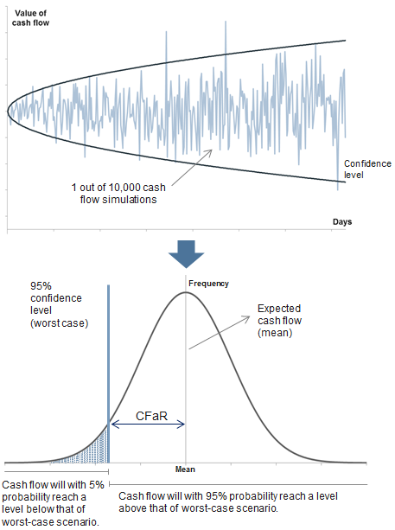

→ GLOSSARY

Start-up stage - newly formed companies without significant operating histories are considered to be in the start-up stage. Most entrepreneurs fund this stage of a company’s development with their own funds as well as investments from angel investors. Angels are wealthy individuals, friends, or family members that personally invest in a company.

Seed stage - seed or early stage rounds often involve investments of less than $5 million for companies that have promising concepts validated by key customers but have not yet achieved cash flow break-even. Organized groups of angel investors as well as early stage venture capital funds usually provide these types of investments.

Growth stage - Growth stage investments focus on companies that have a proven business model and either are already profitable or offer a clear path to sustainable profitability. These investments tend to be in the $5-20 million range and are intended to help the company increase its market penetration significantly.

Late stage - tend to be for relatively mature, profitable companies seeking to raise $10+ million for significant strategic initiatives (i.e. investment in sales & marketing, expansion overseas, major infrastructure build-outs, strategic acquisitions, etc.) that will create major advantages over their competition.

Buyout and recapitalization - are becoming more prevalent for mature technology companies that are stable and profitable. In these transactions, existing shareholders sell some or all of their
shares to a venture capital firm in return for cash. These venture capital firms may also provide additional capital to fuel growth in conjunction with an exit for some or all of the company’s existing shareholders.

→ FORMULAS

The Cash Flow-at-Risk approach derived is defined as follows: The potential monetary decrease of a specific cash flows series will in not on single path, meaning at no point of time, be larger than amount x given a confidentiality level of a and given a considered number of n days until T.

6. Global challenges and risks
Global Financial crises and their consequences. Extreme risk events.

→ LECTURE MATERIALS

6.1. The 1998 crisis at Long Term Capital Management demonstrated the limitations of risk modeling. In the violent market upheavals of 2007–08, many banks reported more than 30 days when losses exceeded VAR, a span in which 3 to 5 such days would be the norm. In 2011, just before the European sovereign crisis got under way, many banks’ risk models treated eurozone government bonds as virtually risk free.
The 2007-2009 financial crisis resulted in the largest realization of bank risk since the Great Depression. The decimation of the market value of banking shares during this period was unprecedented: more than 3 trillion euros were erased from the market capitalisation of banks in Europe and the United States.

6.2 Firms have been working post-crisis to remake their risk governance frameworks, and many of the themes seen in previous years remain a feature of this year’s study. The largest shift this year is a renewed focus on risk culture. While risk culture has been a high priority since the crisis, senior management and boards have become less certain of the culture prevailing in different business units. In addition, management has shifted its focus to operational and reputational risk following high-profile conduct cases.

→ QUIZZES AND EXERCISES

Ex.6.1. Look through the Survey of risk-management after the crises of 2008, provided by EY (See at: http://www.ey.com/Publication/vwLUAssets/Remaking_financial_services_-_risk_management_five_years_after_the_crisis)

Wright an essay titled as follows «Lessons from the Financial Crisis for Risk Management».

LITERATURE

Main literature:
1) Fight A. Credit risk management. – Butterworth-Heinemann, 2004.
2) Doherty N. A. Integrated risk management: Techniques and strategies for managing corporate risk. – New York : McGraw-Hill, 2000.
3) Metrick A., Yasuda A. Venture capital and the finance of innovation. – Hoboken, NJ: Wiley, 2007.
4) McNeil A. J., Frey R., Embrechts P. Quantitative risk management: concepts, techniques, and tools. – Princeton university press, 2010.
5) Linsmeier T. J., Pearson N. D. Value at risk //Financial Analysts Journal. – 2000. – С. 47-67.

Additional literature:
1) Bodie Z., Kane A., Marcus A.J. Essentials of Investment. 5th edition [Text] / Zvi Bodie, Alex Kane, Alan J. Marcus. Essentials of Investment – McGraw Hill Irwin, New York – 2002. – 994 p.
2) Saunders A., Allen L. Credit risk management in and out of the financial crisis: New approaches to value at risk and other paradigms. – John Wiley & Sons, 2010. – Т. 528.
3) Duffie D., Singleton K. J. Credit risk: pricing, measurement, and management. – Princeton University Press, 2012.
4) Stulz R. M. Rethinking risk management //Journal of applied corporate finance. – 1996. – Т. 9. – №. 3. – С. 8-25.
5) Basak S., Shapiro A. Value-at-risk-based risk management: optimal policies and asset prices //Review of Financial studies. – 2001. – Т. 14. – №. 2. – С. 371-405.
6) Duffie D., Pan J. An overview of value at risk //The Journal of derivatives. – 1997. – Т. 4. – №. 3. – С. 7-49.
7) E.I. Altman and A. Saunders, “Credit Risk Measurement Developments Over the Last 20 Years,” Journal of Banking and Finance Vol. 21, No. 11-12 (1998), pp. 1721-1742.
8) N. Andrén, H. Jankensgård, and L. Oxelheim, ”Exposure-Based Cash-Flow-at-Risk: An Alternative to VaR for Industrial Companies,” Journal of Applied Corporate Finance Vol. 17, No. 3 (2005), pp. 76-86.
9) S.M. Bartram, "Corporate Risk Management as a Lever for Shareholder Value Creation”, Financial Markets, Institutions & Instruments, Vol. 9, No. 5 (2000), pp. 279-324.
10) R.C. Merton and A. Perold, “Theory of Risk Capital in Financial Firms”, Journal of Applied Corporate Finance Vol. 6, No 3(1993), pp. 16-32.

Internet resources
- Global association for risk professionals. Available at: http://www.garp.org/
- Boston C. S. F. CreditRisk+: A credit risk management framework //Technical document. – 1997. Available at: http://www.csfb.com/institutional/research/assets/creditrisk.pdf
- De Servigny A., Renault O. Measuring and managing credit risk. – McGraw Hill Professional, 2004.
- Wilfried Paus and others. Measuring and managing credit risk volatility. New Your University Stern school of business, 2013. Available at: https://www.stern.nyu.edu/sites/default/files/assets/documents/con_041706.pdf

